This document covers the alignment of the milling and imaging planes, so that when a new surface is milled, the image is automatically in focus

1. Mount the sample, power on and connect all instruments (mill, microscope, DLP projector), and open the corresponding software (Mach3, LightCrafter Control, MicroManager)
2. Manually jog the sample in X-Y directions to under the milling tool. Jogging is usually controlled by the arrow buttons on the keyboard. The jogging control panel can be activated with the Tab button. 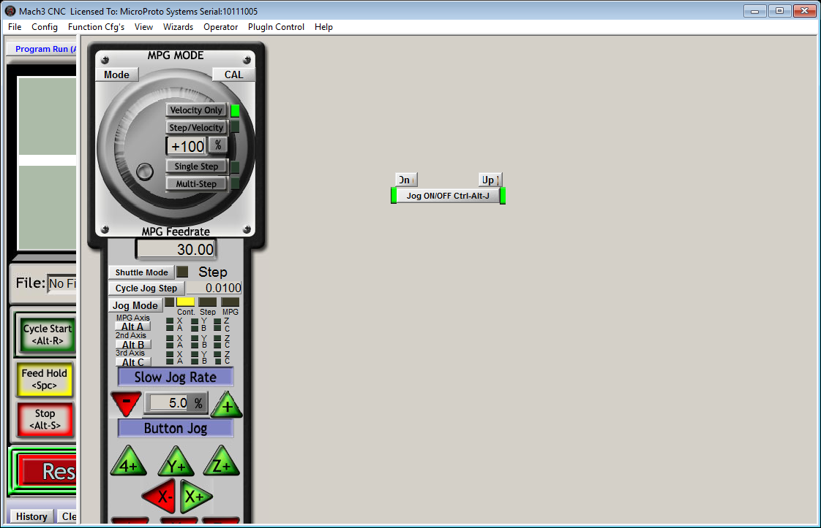
3. Activate spindle (use on-screen button or enter M3 in Diagnostics) and vacuum (M8 in Diagnostics) (This can be done with one line of M3M8 in Diagnostics)  
   
4. Change slow jog rate to a small number (eg. 5) to lower jogging speed, and carefully lower the spinning milling tool in the Z direction (Probably using PgUp and PgDn buttons) until it just takes chips off of the sample
5. At a very slow speed, jog left and right so that the entire top surface is milled.
6. Turn off spindle and vacuum using code M5M9 in Diagnostics
7. Change back to a high jog rate and move the sample back to the imaging position  
   (steps 5, 6, 7 may be done by writing G code like this)  
   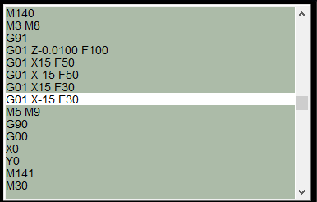
8. In MicroManager, open a Live view window  
   
9. Set light source to appropriate test pattern (eg. solid white)  
   
10. Slowly jog the sample in the X-Y directions so that we are looking at an edge of the sample. Confirm in the Live window  
    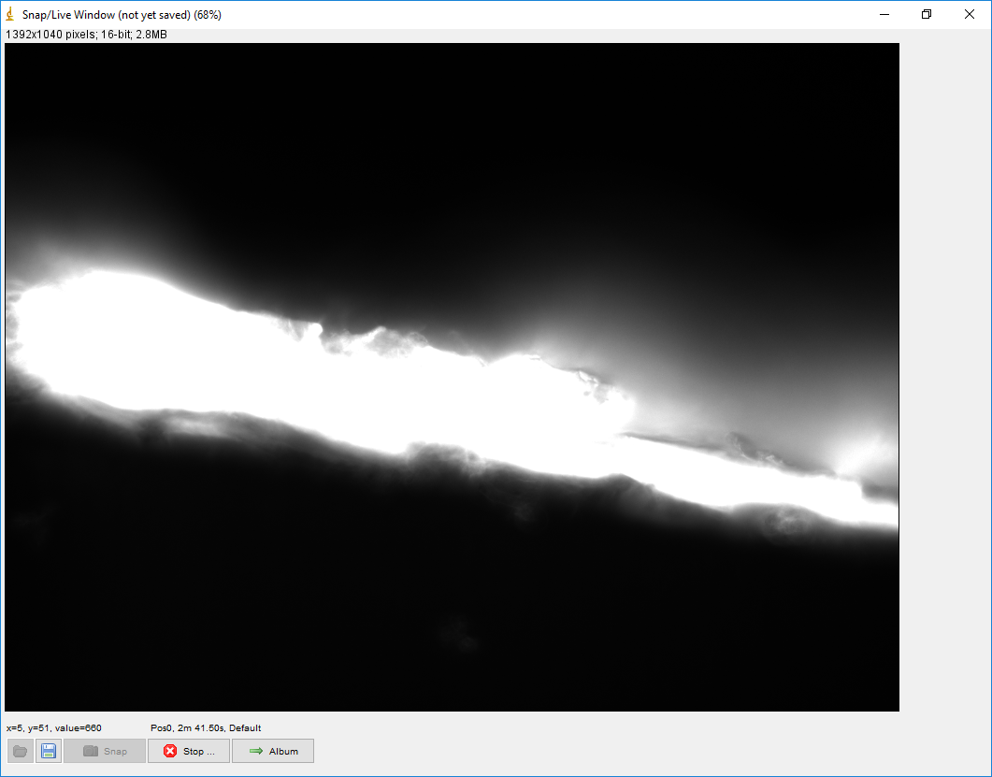
11. Adjust the screw that adjusts the height of the microscope without moving the mill until a clear image is seen in the Live window  
    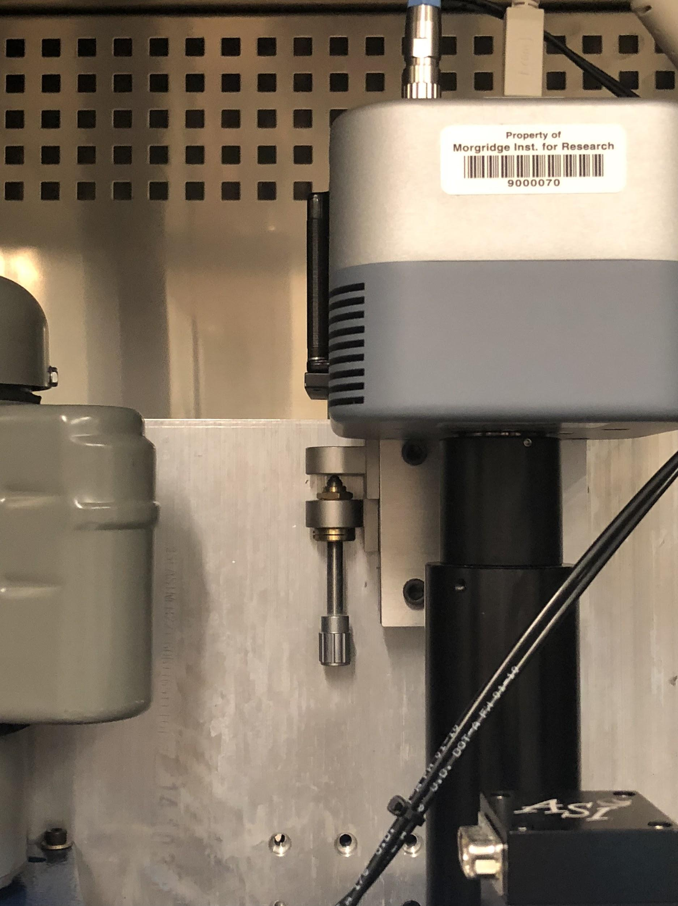
12. Alignment is finished